 | Jurnal Ekobistek  https://jman-upiyptk.org/ojs
  2025 | Vol. 14 | No. 1 | Hal: 1-7 | e-ISSN: 2301-5268, p-ISSN: 2527 - 9483

The Effect Of Training, Workload And Place Of Duty On Employee Discipline
Ronal Regen^{1}, Jamhari², Doni Marlius³, Elva Dona⁴, Teguh Hidayat⁵
^{1,3,4}Akademi Keuangan dan Perbankan Padang
^{2,5}Sekolah Tinggi Ilmu Ekonomi KBP
ronalregen@akbpstie.ac.id

Abstract
Discipline is an attitude, behavior and actions that are in accordance with company regulations both written and unwritten. This study aims to see the effect of training, workload and workplace on employee discipline at the Kayu Aro Sub-District Office both individually and together. The regulations in question include attendance, slow entry, and early return of employees. So this is an employee's indisciplinary attitude that needs to be addressed properly by management. Many interpret discipline as when employees always come and go home on time. That opinion is only one that is demanded by the organization. Therefore, discipline can be defined as behavior that is written or unwritten. The population in this study were all 35 employees of the Kayu Aro Sub-District Office. The technique of determining the number of samples taken as respondents with the technique in taking this sample using total sampling techniques (overall sample). The reason for taking total sampling is because the population is less than 100, the entire population is used as a research sample. The results of this study indicate that training has a positive effect on employee discipline at the Kayu Aro Sub-District Office, workload has a positive effect on employee discipline at the Kayu Aro Sub-District Office, workplace has a positive effect on employee discipline at the Kayu Aro Sub-District Office and training, workload and workplace together have a significant effect on employee discipline at the Kayu Aro Sub-District Office.
Keywords: Discipline, Training, Workload, Duty station, company.
Jurnal Ekobistek is licensed under a Creative Commons 4.0 International License.

Introduction
Discipline is an attitude, behavior and actions that are in accordance with company regulations, both written and unwritten [1]. The regulations in question include attendance, slow entry, and early return of employees. So this is an employee's indisciplinary attitude that needs to be addressed properly by management. Many interpret discipline as when employees always come and go home on time. That opinion is only one that is demanded by the organization. Therefore, discipline can be interpreted as written and unwritten behavior [2].
Government Regulation (PP) Number 94 of 2021 concerning Civil Servant Discipline regulates the obligations, prohibitions, and sanctions for Civil Servants (PNS) in order to improve discipline and professionalism in carrying out their duties. This regulation replaces PP Number 53 of 2010 and strengthens supervision and guidance of civil servants. Civil servants are obliged to obey all statutory provisions, carry out their duties professionally, and maintain their integrity and code of ethics. Civil servants are also required to work in a timely and efficient manner, and report wealth according to the provisions. Along with changes in the work environment and increased demands for public services, stronger and more effective regulatory instruments are needed. The issuance of PP Number 94 of 2021 is expected to be able to answer this challenge by clarifying the obligations and sanctions for civil servants who violate the rules.
Discipline is useful for educating employees to comply with existing rules, procedures, and policies, so that it can produce good performance. Work discipline according an attitude, behavior that is carried out voluntarily and with full awareness and conditions to follow the rules set by the Government, both written and unwritten [3]. The loss of discipline will affect the work efficiency and effectiveness of work [4]. If discipline cannot be enforced, it is likely that the goals that have been set cannot be achieved effectively and efficiently. As an illustration, if a government only pays attention to education, expertise and technology without thinking about the enthusiasm and discipline of employees, then even high education, expertise and technology will not produce maximum products if those concerned cannot utilize them regularly and have high work discipline [5].
According reveals that work discipline is every individual and also a group that ensures compliance with orders and takes the initiative to take the necessary actions if there is an order [6]. Meanwhile, according) discipline is a management action to encourage the implementation of organizational standards, this is training that leads to efforts to justify and involve knowledge of employee attitudes and behavior so that there is a willingness in employees to lead to better cooperation and achievement [7]. Thus this application greatly affects employee discipline. Work discipline which means the willingness to comply with the rules or regulations that apply in the environment of each work organization so that it is expected to improve high performance [8].
The Kayu Aro Sub-District Office as an element of local government organizers that functions to coordinate, organize the formulation of city government policies, prepare information about the Sub-District Office area as material for formulating City Government policies, delegating some of the Mayor's authority, fostering state ideology and national unity, implementing community empowerment, carrying out general government tasks, coordinating the operations of technical implementation units of Departments, Agencies, Offices, Organizing Government Administration, Management of Apparatus Resources, Finance, Infrastructure Facilities. The Sub-District Office is a regional device that has a working area led by the Sub-District Head who is under and responsible to the Mayor through the Regional Secretary.
Table 1. List of Total Employee Tardiness Kayu Aro Sub-District Office During the Year 2024
Mont | Delay Time (person) |  |  | Jumlah  Keterlambatan  (orang) | Persentase  (%)
Mont | < 10  Minutes | 10-15  Minutes | > 15  Minutes | Jumlah  Keterlambatan  (orang) | Persentase  (%)
January | 3 | 2 | 1 | 6 | 16
February | 4 | 3 | 3 | 10 | 26
March | 2 | 3 | 1 | 6 | 16
April | 3 | 2 | 1 | 6 | 16
May | 2 | 1 | 2 | 5 | 13
June | 2 | 4 | 1 | 7 | 18
Average | 3 | 3 | 2 | 7 | 18
From the table above, it can be said that there are still many employees who are late for work with an average for delays < 10 minutes, namely 3 people, for delays of 10-15 minutes, namely 3 people and for delays > 15 minutes, namely 2 people. So that the percentage of tardiness from employees on average from January to June 2024 is 18%. This shows the lack of discipline and obligation of employees for the work given to them.
Table 2. Pre-Survey of Low Employee Work Discipline Kayu Aro Sub-District Office
No. | Indikator | Setuju  (orang) | Tidak Setuju | Persentase  Tidak Setuju  (%)
1. | I never leave work before the end of working hours. | 22 | 16 | 42
2. | I always show up to take attendance | 25 | 13 | 34
3. | In carrying out my work, I always pay attention to the level of work safety. | 27 | 11 | 29
4. | The regulations in my workplace make me more aware of everything around the workplace. | 21 | 17 | 45
From table 1.2 shows the results of the survey as many as 38 people indicator of low work discipline seen from the inaccuracy of employees in completing tasks, as many as 16 people (42%) said disagree that I never leave work before working hours are over. Meanwhile, 17 people (45%) said they disagreed that the regulations in the place where I work make me work more alert to everything around the workplace.
Low employee discipline is thought to be due to training, workload, and place of duty. This is also in accordance with the opinion expressed which states that several factors that can affect organizational discipline are training, workload, and place of duty [9].
From the observation, it was found that there was no evaluation of the training results. One of the important points that support employee discipline is training. This is in accordance with the theory that says “that the purpose of training is to increase morale and in turn will increase discipline” [10]. “Training is an activity of the agency that intends to be able to improve and develop the attitudes, behavior, skills and knowledge of employees, in accordance with the wishes of the agency concerned” [11].
The effect of training on discipline has been studied by previous researchers such which concluded that training has a significant effect on employee discipline. When employees are given training, there will be an increase in employee competence [12]. Increased competence will have an impact on the better employee expertise. Of course, this condition will be able to influence the increase in employee discipline. On the other hand, if employees are not given training, there will be no increase in employee competence. This will not have an impact on improving employee discipline.
In addition, it appears that employee discipline is also not maximized due to workload limitations in terms of technology. Workload is also a factor that affects discipline. This is in accordance with the opinion that states “that the factors that influence discipline are ability and motivation” [13]. “Workload is a result of the work achieved by a person in carrying out the tasks assigned to him based on skills, experience and seriousness and time” According to [14]. Meanwhile, “ability is an individual capacity to perform various tasks in a job” according [15]. This opinion has also not been proven empirically, especially in the Kayu Aro Sub-District Office.
The results of previous research also show that workload can have a positive impact on discipline. The results of this study were found [16]. The conclusion of the study is that if the workload of employees increases, the ability of employees, both technical and non-technical, will be better. Basically, this condition will have a positive effect on improving employee discipline. Conversely, if employee workload is low, employee discipline will also be low.
Another factor that can affect employee discipline is the place of duty. This is in accordance with the opinion that states “that the outcomes of the task place are high discipline, low employee turnover and low absenteeism” [17]. “Place of duty as a level where individuals identify and are involved with their organization and/or do not want to leave it” according [18]. “Place of duty or worker loyalty is the degree to which workers identify with the organization and want to continue to actively participate [19].
In line with the theory above, the results of previous research also show that a strong place of duty will encourage better employee discipline because employees have high determination and loyalty so they want to work well. Conversely, a lack of a place of duty will reduce employee discipline because employees feel disloyal and not firm in their hearts to the organization. Thus, discipline will not be maximized. The findings of this study were concluded [20]
Based on the phenomenon of problems and the results of previous research, this study tries to develop and analyze the influence of training variables, workloadThis analysis is used to determine whether the independent variables have a correlation with each other or not. If there is a high correlation, it means that there is a multicollinearity problem. If the VIF value is less than 10 and or the Tolerance value is more than 0.01, it can be firmly concluded that there is no multicollinearity problem. If the intercorrelation price between independent variables is smaller or equal to 0.800, there is no multicollinearity. and place of duty on discipline with the title “The Effect of Training, Workload and Place of Duty on Employee Discipline at the Kayu Aro Sub-District Office.

Research Method
The technique in this sampling uses total sampling technique (overall sample), total sampling is a sampling technique where the number of samples is the same as the population (Sugiyono, 2017). The reason for taking total sampling is because according to (Sugiyono, 2017) the population of less than 100 the entire population is used as a research sample. So the sample in this study was taken from all members of the population, namely employees of the Kayu Aro Sub-District Office, which was also 35 people.
Validity Test
The rtable value is seen in the r table with df = n-2 (n = number of respondents / samples) with a significance level of 5% (0.05). If the result of rcount> table, then the statement is valid, otherwise if rcount< table, then the statement is invalid.
The statistical technique that can be used is correlation.
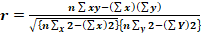
Reliability Test
Reliability is a test tool to determine the reliability of a variable or the extent to which the measurement results have consistency when measured several times on the same symptoms. The high and low reliability is indicated by a Cronbach Alpha (α) coefficient number ≥ 0.60. If Cronbach Alpha (α) is greater than or equal to 0.60, the research variable is declared reliable, and vice versa if Cronbach Alpha is smaller than 0.60, the research variable is declared unreliable. Calculation of the reliability test will be carried out with the help of the SPSS (statistical package for social science) version 21.0 program. Reliability testing using the Cronbach Alpha formula is as follows:
Normality Test
The normality test aims to test whether in the regression model, confounding or residual variables have a normal distribution. The test is carried out using the Kolmogorov-Smirnov test method for each variable. The regression model is normally distributed if the Kolmogorov-Smirnov sign value of each variable is greater than α = 0.05 which compares the observed data with a distribution that is close to the normal distribution.
Multicollinearity Test
Multicollinearity test is a test conducted to ascertain whether in a regression model there is intercorrelation or collinearity between independent variables. Intercorrelation is a linear relationship or strong relationship between one independent variable and another in a regression model. The intercorrelation can be seen by the correlation coefficient between the independent variables, the VIF and Tolerance values, the Eigenvalue and Condition Index values, and the standard error value of the beta coefficient or partial regression coefficient
Multiple Linear Regression Analysis
Hypothesis testing in this study uses multiple linear regression analysis. Multiple linear regression analysis aims to determine the causal relationship between the variables that influence and the variables that are influenced. With the multiple regression equation model as follows:
Y = a + b1 X1 + b2 X2 + b3 X3 +e
F statistical test
The F statistical test is used to determine whether the regression model used is appropriate in presenting the research data.
statistical test
The t statistical test to see whether the independent variables X1, X2, X3 have a significant effect on the dependent variable Y in the regression equation used, it is necessary to test the hypothesis using the t statistical test, namely comparing the tcount value with the ttable value at df = n-k.
Double Determination Coefficient (R2)
To determine the size of the influence of the independent variable on the dependent variable is determined by the coefficient of multiple determination (R2). To measure the magnitude of the influence of the independent variable on the dependent variable, the coefficient of multiple determination (R2) is used.

Result and Discussion
Normality Test
In this normality test using the graph method, namely by looking at the distribution of data on the diagonal source on the Normal Probability (P-P Plot) graph. The following can be seen in figure 1.
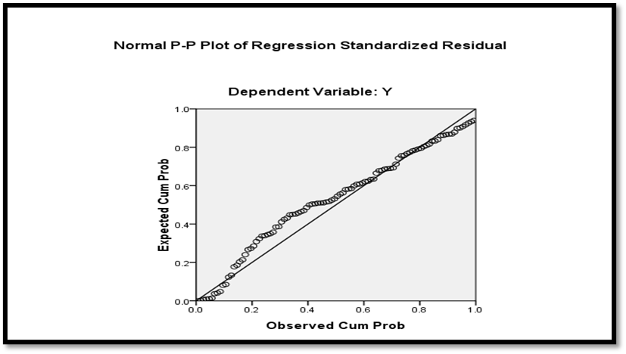
Figure 1. P-P Plot Graph
From Figure 1it can be seen that the points spread around the line and follow the diagonal line, so the data is normally distributed or the regression model fulfills the assumption of normality. Apart from using the graph method, it is also done by looking at the histogram of the residuals. The results can be seen in Figure 1.
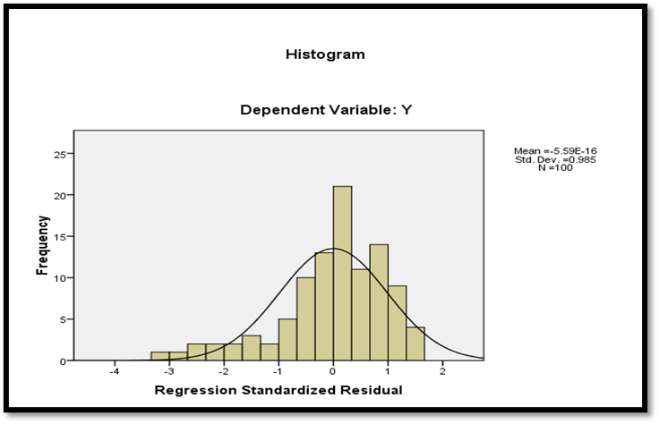
Based on Figure 2. above, the Regression Residual histogram forms a bell-like curve, so the residual value is declared normal or normally distributed data. In addition, the One-Sample Kolmogorov-Smirnov test method is also carried out which is contained in table 2.

Table 3. Kolmogorov-Smirnov Test Results

One-Sample Kolmogorov-Smirnov Test
 |  | Y | X₁ | X₂ | X₃
N |  | 35 | 35 | 35 | 35
Normal Parametersª | Mean | 43.7500 | 42.3100 | 43.6300 | 43.7300
Normal Parametersª | Std. Deviation | 3.22983 | 3.02747 | 3.24630 | 2.89149
Most Extreme Differences | Absolute | .181 | .130 | .095 | .140
Most Extreme Differences | Positive | .073 | .073 | .057 | .079
Most Extreme Differences | Negative | -.181 | -.130 | -.095 | -.140
Kolmogorov-Smirnov Z |  | 1.808 | 1.301 | .954 | 1.397
Asymp. Sig. (2-tailed) |  | .103 | .268 | .323 | .240

Based on table 3. above, it shows that the significance value (Asymp.Sig. 2-tailed) Y is 0.103, X1 is 0.268, X2 is 0.323, X3 is 0.240. Because the significance value is greater than 0.05 (Sig. > α), the residual value is normally distributed.
Multicollinearity Test
To detect multicollinearity, it can be done by looking at the Tolerance and Variance Inflation Factor (VIF) values and the amount of correlation between independent variables. Table 4 shows the results of the multicolonierity test in this study.
Multicollinearity Test
To detect multicollinearity, it can be done by looking at the Tolerance and Variance Inflation Factor (VIF) values and the amount of correlation between independent variables. Table 4 shows the results of the multicolonierity test in this study.
Table 4. Multicollinearity Test Results
Variabel | Tolerance | VIF
X₁ | .956 | 1.046
X₂ | .954 | 1.048
X₃ | .950 | 1.052

Based on table 4 above, it can be seen that the tolerance value is greater than 0.10 and the Variance Inflation Factor (VIF) value is less than 10 for each variable, which is indicated by a tolerance value of 0.956 for training, 0.954 for workload, and 0.950 for workplace. In addition, the VIF value for training is 1.046, workload is 1.048, and place of duty is 1.052. A regression model is said to be free from multicollinearity problems if it has a VIF value of less than 10. Thus, it can be concluded that there is no multicollinearity and can be used in this study.
Heteroscedasticity Test
The heteroscedasticity test is conducted to test whether in a regression model there is an inequality of variance from the residuals of one observation to another. Detection of the presence or absence of heteroscedasticity is done by looking at the presence or absence of certain patterns in the scatterplot graph between SRESID and ZPRED, which is shown in Figure 5. below.
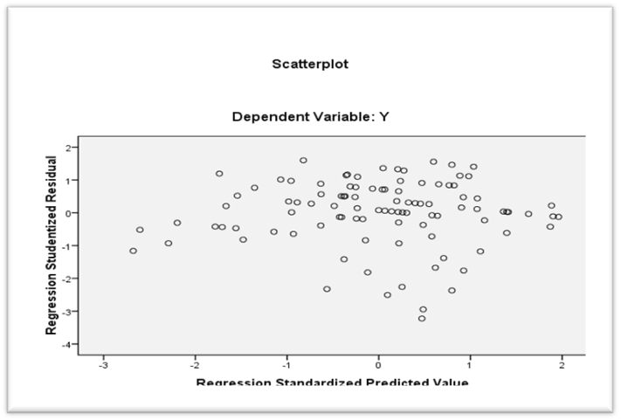
Figure 5. Scatterplot Test Results
From Figure 5. above, the scatterplot shows that there is no clear pattern and the points spread above and below the number 0 on the Y axis. This means that there is no heteroscedasticity in the regression model. Thus, it can be concluded that there is no heteroscedasticity in the regression equation model so that the regression model is suitable for predicting employee discipline based on the variables that influence it, namely training, workload and workplace. Apart from using the scatterplot graph, the Glejser test is also used.

Table 6. Glejser Test Results

Model | Uns.Coef. |  | Stan.C | t | Sig.
Model | B | Std. Error | Beta | t | Sig.
C | -3.585 | 5.532 |  | -.648 | .518
X₁ | .093 | .071 | .135 | 1.306 | .195
X₂ | .047 | .067 | .074 | .711 | .479
X₃ | -.003 | .075 | -.004 | -.037 | .971
Based on table 6. above, it can be seen that each independent variable, namely training, work discipline and workplace has a Sig. value greater than 0.05, so it can be concluded that there is no heteroscedasticity. This is consistent with the results of the scatterplot test. Multiple Linear Analysis
In testing the hypothesis of this study, multiple linear regression tests were used, which aim to determine how much influence several independent variables have on the dependent variable. Multiple regression analysis is done by comparing tcount with ttable and sig value with α = 0.05. In detail the results of multiple regression testing can be seen in Table 7.
Table 7. Statistical Test Results t
Model | Unstandardized  Coefficients |  | St.Co | T | Sig.
Model | B | Std. Error | Beta
(Constant) | 71.855 | 8.339 |  | 8.616 | .000
Pelatihan | .361 | .108 | .057 | 3.342 | .001
Beban kerja | -.436 | .100 | .137 | -4.360 | .000
Tempat tugas | .595 | .113 | .175 | 5.265 | .000
Based on table 7. the regression equation is obtained as follows:
Y = 71.855 + 0.361 X₁ - 0.436 X₂ + 0.595 X₃ + e
Based on the equation above, it can be explained that:
a. From the above equation it can be seen that there is a constant value of 71.855 which means that if training, workload, and place of duty are zero, then the value of the discipline variable is 71.855. This means that the variables of training, workload, and place of duty contribute to increasing the discipline of employees of the Kayu Aro Sub-District Office.
b. The training regression coefficient value is positive 0.361. This means that if training increases by one unit, it will result in an increase in discipline by 0.361 units.
c. The workload regression coefficient value is negative, namely -0.436. this means that if the workload increases by one unit, it will result in a decrease in employee discipline at the Kayu Aro Sub-District Office by 0.436 units.
d. The regression coefficient value of the place of duty is positive, namely 0.595. This means that if the place of duty increases by one unit, it will result in an increase in employee discipline at the Kayu Aro Sub-District Office by 0.595 units
Statistical Test t
a. Hypothesis Testing 1
The first hypothesis proposed, that training partially has a positive effect on employee discipline at the Kayu Aro Sub-District Office. Based on the analysis results of the t test, it is known that the significance level of the training variable is 0.001 < than the significance value (0.05). Thus Ho is rejected and Ha is accepted. So that the alternative hypothesis proposed in this study is accepted, meaning that there is a significant positive effect between training and employee discipline at the Kayu Aro Sub-District Office.
b. Hypothesis 2 Testing
The second hypothesis proposed, that workload partially has a positive effect on employee discipline at the Kayu Aro Sub-District Office. Based on the analysis results of the t test, it is known that the significance level of the workload variable is 0.000 < than the significance value (0.05). Thus Ho is rejected and Ha is accepted. So that the alternative hypothesis proposed in this study is accepted, meaning that there is a significant positive influence between workload on employee discipline at the Kayu Aro Sub-District Office.
c. Hypothesis Testing 3
The third hypothesis proposed, that the place of duty partially has a positive effect on discipline. Based on the analysis results of the t test, it is known that the significance level of the task place variable is 0.000 < than the significance value (0.05). Thus Ho is rejected and Ha is accepted. So that the alternative hypothesis proposed in this study is accepted, meaning that there is a significant positive influence between the place of duty on the discipline of employees of the Kayu Aro Sub-District Office.
F Statistical Test
Table 8. below illustrates the results of the F statistical test.
Table 8. F Statistical Test Results
Model |  | F | Sig.
1 | Regression | 9.286 | .000ª
 | Residual
 | Total
d. Hypothesis 4 Testing
The fourth hypothesis proposed, that training, workload, and workplace together have a positive effect on employee discipline at the Kayu Aro Sub-District Office. Based on the analysis results of the F test, it is known that the significance level of the training, workload, and duty station variables is 0.000 <0.05. Thus Ho is rejected and Ha is accepted. So that the alternative hypothesis proposed in this study is accepted, meaning that there is a significant influence together between training, workload, and place of duty on employee discipline at the Kayu Aro Sub-District Office.
Test Coefficient of Determination (R2)
Table 9. Below illustrates the results of the R2 coefficient of determination test.
R2 Determinant Coefficient Test Results
Model | R | R Square | Ad. R Square | Std. Error
1 | .858ª | .736 | .701 | 3.16870
Table 4.16 shows the Adjusted R Square value of 0.701 or 70.1%. These results indicate that the employee discipline variable that can be explained by the training, workload and duty station variables is 70.1%. While the difference of 0.299 or 29.9% (100% -70.1%) is explained by other variables or variables not examined by the author such as leadership, work environment, organizational culture, competence and compensation.

Conclusion
Based on the research and discussion that has been carried out regarding the effect of training, workload and place of duty on employee discipline at the Kayu Aro Sub-District Office, conclusions can be drawn regarding the effect of training, workload and place of duty partially and simultaneously on employee discipline. The conclusion of this study is that training has a significant effect on employee discipline at the Kayu Aro Sub-District Office, workload has a significant effect on employee discipline at the Kayu Aro Sub-District Office, place of duty has a significant effect on employee discipline at the Kayu Aro Sub-District Office, and training, workload and place of duty) together have a significant effect on employee discipline at the Kayu Aro Sub-District Office.

References
- Sinambela, S. (2020). The Effect of Workload on Job Stress, Work Motivation, and Employee Performance. International Journal of Psychosocial Rehabilitation, 24(04), 1373–1390. https://doi.org/10.37200/ijpr/v24i4/pr201109
- Sulastri, S. (2020). The Effect of Work Stress and Workload on Employee Performance. https://doi.org/10.31219/osf.io/nvjqf
- Aulia Choirunnisa, Prabowo, H., & M.Fadjar Darmaputra. (2023). Effect of Workload, Job Stress and Job Training on Employee Performance at Bank BPR BKK Semarang. Journal of Finance and Business Digital, 2(1), 29–42. https://doi.org/10.55927/jfbd.v2i1.3324
- Budilestari, I., Sundjot, S., & Rahayu, S. (2024). The Effect of Workload and Employee Engagement on Job Satisfaction at the Inspectorate of East Java Province. International Journal of Research Publication and Reviews, 5(1), 2743–2750. https://doi.org/10.55248/gengpi.5.0124.0305
- ZamirKhan, A. D. L., Rubel, M. R. B., & Kee, D. M. H. (2024). Exploring the effect of psychosocial safety climate on employee outcomes: the moderating roles of workload and organizational training. Journal of Advances in Management Research. https://doi.org/10.1108/jamr-04-2023-0096
- Ismiyanti, I., & Andriyani, D. (2022). The Effect of Job Placement and Job Satisfaction on Employee Performance with Employee Engagement as an Intervening Variable. Academia Open, 7. https://doi.org/10.21070/acopen.7.2022.3335
- Anwar, D. N. A. F., & Firdaus, V. (2023). Analyzing Factors Affecting Employee Productivity: Training, Discipline, and Experience. Academia Open, 8(1). https://doi.org/10.21070/acopen.8.2023.4131
- Prastyo, M. I. B., & Andriani, D. (2022). The Effect of Workload and Work Stress on Turnover Intention with Job Satisfaction as an Intervening Variable for Employees. Academia Open, 7. https://doi.org/10.21070/acopen.7.2022.2666
- Haidar, T. B. O., & Abadiyah, R. (2022). The Effect of Work Family Conflict, Work Environment, and Work Stress on Employee Burnout. Academia Open, 7. https://doi.org/10.21070/acopen.7.2022.3414
- Giovany, R., & Suyana, H. (2024). Enhancing Employee Performance: The Effect of Job Satisfaction, Motivation, Workload, and Work Discipline. Human Capital and Organizations, 2(1), 24–34. https://doi.org/10.58777/hco.v2i1.276
- Juana, S., Ali, H., & Imron Rosadi, K. (2023). Effect of Workload, Work Discipline and Work Motivation on Employee Performance. International Journal of Advanced Multidisciplinary, 2(2), 535–541. https://doi.org/10.38035/ijam.v2i2.333
- Wiguna, M. (2020). The Effect of Discipline and Training Toward Employee Performance. Almana : Jurnal Manajemen Dan Bisnis, 4(2), 197–204. https://doi.org/10.36555/almana.v4i2.1353
- Wulandari, F. C., Cik, A., & Digdowiseiso, K. (2024). The Effect of Workload, Discipline, and Motivation on Employee Performance at Vania Hospital Bogor City. Journal of Social Science, 5(1), 199–215. https://doi.org/10.46799/jss.v5i1.774
- Putra, M., & Syuhada, W. (2023). The Effect of Workload and Work Discipline on Employee Performance in PT Hirose Electric. International Journal of Research and Review, 10(8), 558–562. https://doi.org/10.52403/ijrr.20230874
- Kurniawan, R. (2023). Analysis of Workload, Competence, and Workplace Discipline Effects on Employee Performance. PRODUKTIF: Jurnal Kepegawaian Dan Organisasi, 2(1), 30–40. https://doi.org/10.37481/jko.v2i1.84
- Maduningtias, L. (2020). The Effect of Working Discipline and Training on Employee Performance (at PT. Transkom Indonesia in Tangerang). PINISI Discretion Review, 1(2), 65. https://doi.org/10.26858/pdr.v1i2.13046
- Sari, M. I., Krisnandi, H., & Digdowiseiso, K. (2024). The Effect of Workload, Career Development and Work Discipline on Employee Performance at Asia Energy Transformation Foundation. Jurnal Syntax Admiration, 4(12), 2557–2567. https://doi.org/10.46799/jsa.v5i1.1011
- Desita, W., Ismartaya, & Yulianingsih. (2024). Influence of Work Discipline, Work Motivation and Workload on Employee Productivity. International Journal of Management and Business Intelligence, 2(2), 99–108. https://doi.org/10.59890/ijmbi.v2i2.1543
- Agrasadya, A. (2020). Effect of Work Discipline and Training on Employee Performance of PT Federal International Finance Depok Branch. Jurnal Ilmiah Ilmu Administrasi Publik, 10(1), 15. https://doi.org/10.26858/jiap.v10i1.13565
- Putri, A. L., Cik, A., & Digdowiseiso, K. (2024). The Effect of Training, Compensation and Work Discipline on Employee Performance at PT. Pegadaian. Journal of Social Science, 5(1), 188–198. https://doi.org/10.46799/jss.v5i1.779

